**Help to Reclaim Belfast’s Cycle Lanes - record Belfast’s blocked cycle lanes, morning and evening, for 5 working days from Monday 5th November to Friday 9th November 2012.**

Simply count the number of parked cars, vans or other blockages on your route. These must be illegally parked vehicles - on an operational bus lane, a mandatory cycle lane, or an advisory cycle lane with operational urban clearway – more information below.

Record the relevant details at the end of your journey on the attached survey sheet. At the end of the week, return your findings for analysis and consolidation into a single snapshot of cyclists’ experience across Belfast. This will be conducted by researchers at the Centre of Excellence for Public Health at Queen’s University Belfast.

Please drop an email to **nigreenways AT gmail.com** if you intend to participate, as we hope to cover all of Belfast during the week, and may need to seek out volunteers for specific areas.

**What is illegal parking and what isn’t?**

Take a look at the road signs on your commuting route. Urban clearways are stretches of road meant to be clear during rush hour periods. Check the operational times to know what’s allowed and what’s not on your road. Some roads will only have an urban clearway going ‘with the flow’ of rush hour traffic.

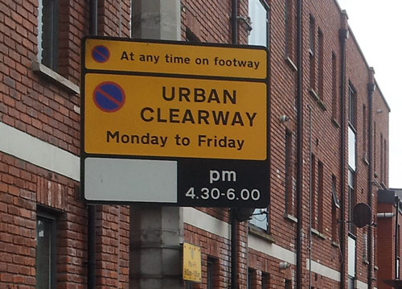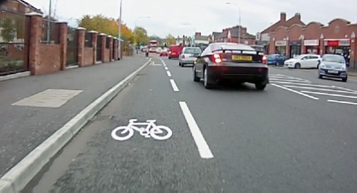**Advisory cycle lane**: distinguished by a broken white line – other vehicles are allowed to drive or park within these lanes. However it is illegal to park a vehicle on, or block an advisory cycle lane, if there is an **operational urban clearway** in the same location – check the operational times.

**Mandatory cycle lane**: this is indicated by a continuous white line, or physical separation from the road – it is illegal for vehicles to drive or park in this lane.

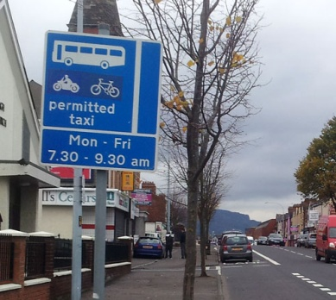**Bus lanes**: usually marked by an unbroken thick white line, and have specific times of operation. Usually a ‘bus lane’ is actually space shared with bicycles, permitted taxis (those permitted to be hired from the street eg black cabs, wheelchair accessible taxis) and motorcycles. Some bus lanes have specific operational times, or may only permit buses and cycles – check the blue signs on your route.

Roads Service says it is doing a good job to encourage more cycling in Belfast; we know the daily reality is different.

Collective independent action by the growing community of Belfast commuter cyclists is needed to **reclaim our cycle lanes**!

Name:

*Record the number of cars parked illegally in an urban clearway that has a clearly demarcated cycle lane, or an operational bus lane*

|  |  |  |  |  |  |  |  |  |  |  |
| --- | --- | --- | --- | --- | --- | --- | --- | --- | --- | --- |
|  | Day | AM/PM | Method of travel | Start point | Start time | Route | End point | End time | No. Illegal blockages | In a cycle lane or bus lane? |
| 1 |  |  |  |  | : |  |  | : |  |  |
| 2 |  |  |  |  | : |  |  | : |  |  |
| 3 |  |  |  |  | : |  |  | : |  |  |
| 4 |  |  |  |  | : |  |  | : |  |  |
| 5 |  |  |  |  | : |  |  | : |  |  |
| 6 |  |  |  |  | : |  |  | : |  |  |
| 7 |  |  |  |  | : |  |  | : |  |  |
| 8 |  |  |  |  | : |  |  | : |  |  |
| 9 |  |  |  |  | : |  |  | : |  |  |
| 10 |  |  |  |  | : |  |  | : |  |  |

**Important points to note:**

* Participation in this survey is entirely voluntary with the understanding and acceptance of the personal risks involved
* No-one connected with the organisation of the survey shall bear any liability for injury or actions of those who take part
* However you choose to travel these routes, don’t let anything distract you from the usual hazards on the road and other road users
* This survey should not be used to identify or harass individuals who may have parked illegally – let’s concentrate on policy, not punters
* We trust volunteers will provide a fair and accurate record of cycle lane blockages - false reporting will only harm the potential outcome
* You can record this data whether you’re cycling, walking, driving or taking the bus – just note the method of travel for each journey
* No identifying information (names, departure / destination points) from participants will be used for reporting purposes